**Retail Sales Analysis Report**

**Introduction**

In today's data-driven business environment, leveraging advanced analytics tools like Power BI and Data Analysis Expressions (DAX) is essential for unlocking actionable insights from large datasets. This introduction sets the stage for the report by highlighting the significance of utilizing Power BI for data modeling through a Dimensional Data Model approach. It emphasizes the importance of DAX in conducting advanced data analysis and underscores the objective of creating a comprehensive report and dashboard based on the provided dataset.

**Problem Statement**

The objective is to leverage Data Analysis Expressions (DAX) to create new calculated measures and columns (KPIs) based on our understanding of the dataset. We will utilize online examples and resources to enhance our analysis.

**Aim**

Our aim is to employ Power BI for data modeling through a Dimensional Data Model approach, integrating DAX for advanced data analysis. Subsequently, we will construct a comprehensive report and dashboard based on the provided dataset.

**Solution**

Our approach begins with the creation of calculated measures using DAX. These measures enable us to perform intricate calculations on the dataset, facilitating deeper data analysis. Following this, we design and implement a dashboard within Power BI. The dashboard acts as a visual representation of our analyzed data, providing key insights and metrics in a user-friendly format.

**Dashboard Screenshots**

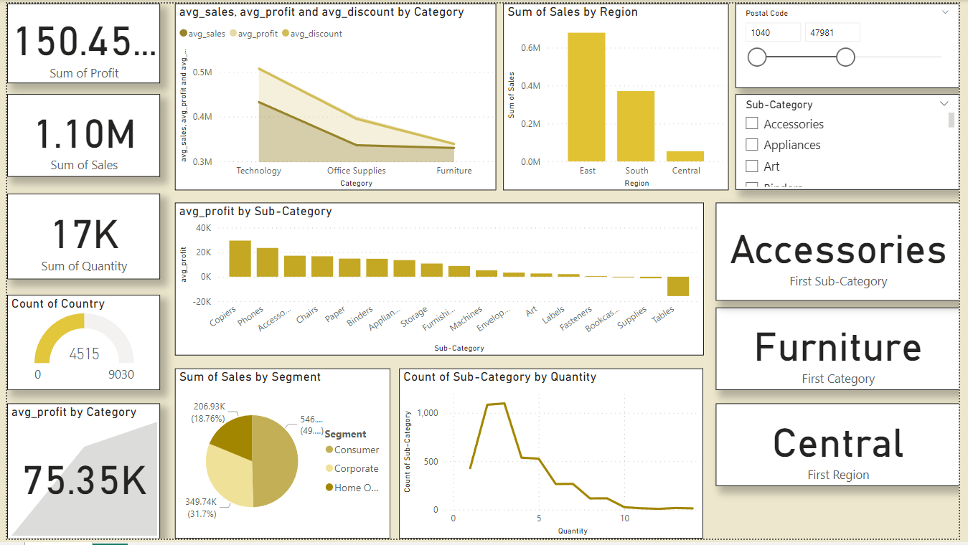

**Conclusion**

Through this project, we have successfully applied DAX to generate new measures and columns, enhancing our dataset's analytical capabilities. Additionally, we have utilized Power BI to create an intuitive dashboard, enabling stakeholders to derive actionable insights from the data.